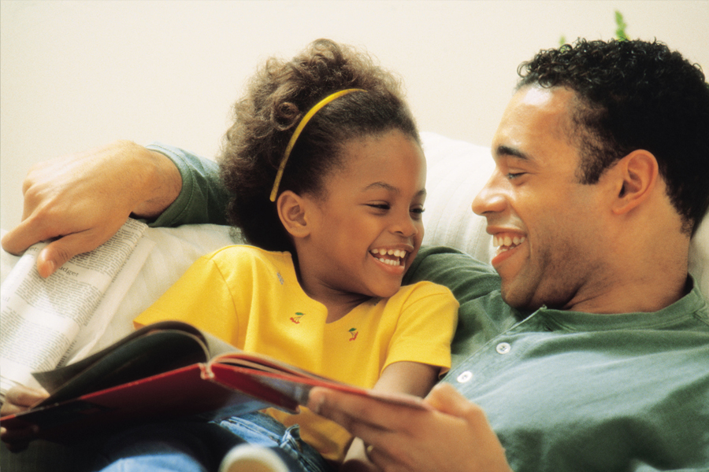

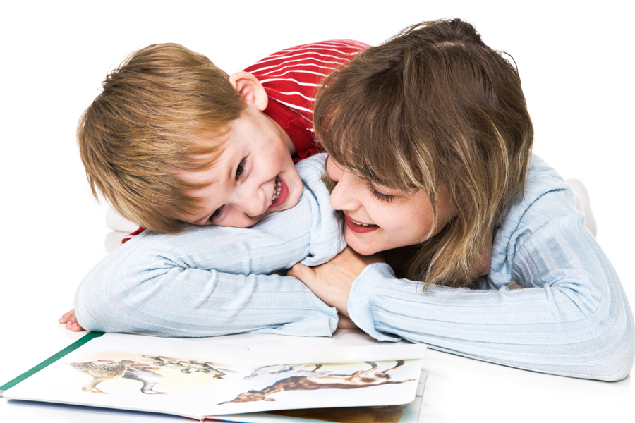

Let’s Take a Book Picture Walk
A picture walk helps develop your children’s
language and pre-reading skills.

- Have a conversation with your child around a book before you read it.
- A picture walk is not reading the book. It’s talking about the pictures—getting to know the book together.
- Speak in the language that is most comfortable for YOU!

What to do:
- Look at the cover.
- Point to and say name of author and title.
- Looking at the cover, ask your child what he thinks the book will be about.
- Without reading the words in the book, encourage your child to turn the pages one at a time.
- Allow time for your child to respond to what you say
—5 seconds.
- Point to a picture and ask, what questions—“What’s this?” “What do you think is happening?
- Follow your child’s lead.
- Repeat what your child says and wait. This is one good way to encourage them to speak more.
- Remember to take turns talking.
- Ask questions to discuss what your child thinks is happening. Examples:
- What is happening on this page?
- Where do you think they are going?
- What might happen next?
- I wonder what would happen if . . .
- What do you think . . . ?
- Acknowledge what your child says.
- Introduce or explain words and what they mean.
- Add a bit more information to what the child says.
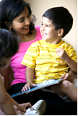
- Help your child make connections to past experiences and future events. Examples:
- When did you . . . ?
- How did you feel when. . . ?
- How would you feel if . . . ?

Let’s Share a Book Together

There are many ways to read books with your children. Children often like to hear the same book over and over again. You can share the same book in different ways each time you read it. Here are some ways you and your child can share books together.

- Encourage your child to turn the pages.
- Have your child tell a story from the pictures.
- Look at the pictures on one page. What do they make you and your child think about? Talk about them together.
- Read the story straight through to get the flow of the story. There may be short interactions with your child.
- Have your child join in with a repeated word or phrase.
- When reading books with repeated phrases or actions, or rhyming books, stop before the end of a line and let your child finish it.
- Ask questions to involve your child—“What do you think is happening here?”
- Ask open-ended questions: “What would you do if that happened to you? How would you feel? Why do you think happened?”
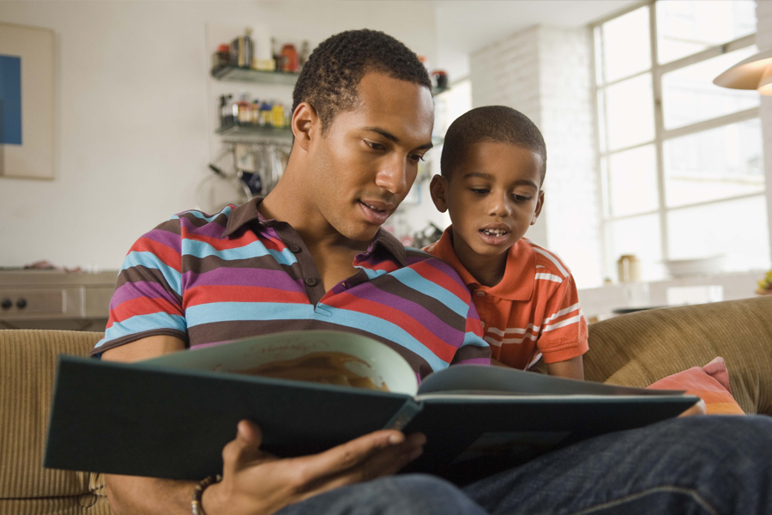
- Repeat what your child says. Add details and use new words.
- Explain words your child does not know.
- Wait for your child to ask questions or make comments.
- After reading the book, talk about what your child said during the picture walk. Did the story end the way your child thought it would or did your child have another idea?
- Ask questions that prompt your child to reflect on the story. Examples:
- How would you have solved this problem?
- Now that you know what happened, why do you think the character acted that way?
- How was the story different from what you thought would happen?

